REV. |  | Description |  |  |  |  |  | Date
00 |  | SPEC ISSUE (NEW MODEL)  ADP-65VE BA |  |  |  |  |  | 12/10’21
01 |  | 102A-221177  1. Item 5. Output Specification Table update.And add Test plan.  2. Item 4.c. OVP test update.  3. ITEM 5. Dynamic Load spec update, 5V=4.5V~6V.  4. Add ITEM 6.4 Surface temperature.  5. ITEM 5. Overshoot update.  6. ITEM 5. add line cycle dropout.  7. ITEM 5. update Hold up time/Line Regulation /Load Combine Regulation/Overshoot/Ripple & Noise/Dynamic Load/Over Current Protection/Input Current/Average Efficiency; Load condition.  8. ITEM 5 Ripple & Noise update |  |  |  |  |  | 01/28’22
02 |  | 102A-221179  1. Item.3-g:Add photo.  2. Item.3-i:Revise 系統電容1000uF.  3. Add Item.3-k: Add 專用DC cable型號:  4. Item.3-a:Revise AC turn on時輸出電流設定.  5. Item.5 Revise Line Regulation 5V=4.5~5.25V  6. Item.5 Revise Load/Combine Regulation 5v=4.5~5.25V  7. Item.5 Revise Dynamic Load 5V=4.25V~6V.  8. Item.5 Revise Peak Load1~3 5V=3.5V~6V.  9. Item.5 AC Line cycle dropout 5V=4.5~5.25V.  10. Item.5 overshoot 5V=5.6v for產線測試. |  |  |  |  |  | 02/17’22
03 |  | 102A-222167  1. Item 4.c OVP 5V spec revise to 8V;ovp test setup revise to "7.4V".  2. Item 5. Test item: Peak load 1-3, 5V standard revise to "3V~6V".  3. Item 5. Test item: OCP standard revise to "full load+0.1A~8A". |  |  |  |  |  | 03/04’22
04 |  | 102A-225003  Section5 item"peak load1"/"peak load2"/"peak load3" remove 5V peak load required. |  |  |  |  |  | 05/06’22
05 |  | 102A-226003  1. Revise item 3.g AC cable 使用1.8m,不加阻抗匹配.接地線靠近LOAD處需加core  並纏繞3ts,core型號C0900B-1.  2. Revise item 5. Pin at stand by load only for 20V.  3. Item 3.c loop gain add "測試時輸出端須加掛1000uf系統電容" |  |  |  |  |  | 06/09’22
06 |  | 102A-226151  ITEM 5. Average efficiency add Remark"Vo須由adapter端取樣"  ADD ITEM 3.l Acoustic noise須使用市電做測試並於輸出加掛1000uF系統電容. |  |  |  |  |  | 06/24’22
 |  |  |  | 台達電子工業股份有限公司  DELTA ELECTRONICS, INC. |  |  | DESCRIPTION :  測試規格(Test Specification)
 | THESE DRAWINGS AND SPECIFICATIONS ARE THE PROPERTY OF DELTA  ELECTRONICS, INC. AND SHALL NOT BE REPRODUCED OR USED AS THE  BASIS FOR THE MANUFACTURE OR SELL OF APPARATUSES OR DEVICES  WITHOUT PERMISSION. |  |  |  |  |  | MODEL NO. :  ADP-65VE B SERIES
 | Date |  | Drawn |  | Design (EE) | Design (ME) | DOCUMENT NAME. :  TS-65VE B SERIES |  | REV.
 | 03/20’24 |  | 王玉玲 |  | 陳新淵 | 陳威堯 |  |  | 14
FRAME NAME:DF-PSLA4V-2R01.DOC SHEET 2 OF 14
REV. | Description | Date
07 | 102A-228072  UPDATE ITEM 3.i 測試ATS/PLD/ESD/EFT時,治具板須掛1000uF/25V之系統電容. | 08/10’22
08 | 102A-229023  1. Section5. “Pin at standby Load” Remark revise:”1. Only for 20V;2. 0.25W cpk不判定.”  2. Section3.g revise to :”接地線靠近插座處需加core並纏繞3ts”.  3. Seciton3.l “acoustic noise test” add below description:”另測試冷機時須測試0%,10%,20%,50%,100%load之噪音,熱機時只需測試50%,100%load之噪音.”  4. Add Section3.m “低溫測試只需滿足客戶規格0 degC,不需加嚴.”  5. Add Section3.n “因客戶的5V/9V系統不支援有線網路卡,故5V/9V輸出時不需測試ISN.” | 09/06’22
09 | 102A-229194  ADD MODEL: ADP-65VE BA9  102A-229212  ADD MODEL: ADP-65VE BA77 | 10/03’22
10 | 102A-22B191  ADD ITEM 9. 瓦數分配 | 11/30’22
11 | 102A-22C156  ADD MODEL: ADP-65VE BB | 12/30’22
12 | 102A-236241  6.1 HI-POT test:  6.1.1 Lo-Limit change from 0.02A to 0.02mA. | 07/01’23
13 | 102A-237224  ITEM 3. 測試注意事項l. “Acoustic noise須使用市電做測試並於輸出加掛1000uF系統電容”  change to "Acoustic noise 須使用自耦變壓器做測試並於輸出加掛1000uF 系統電容" | 07/20’23
14 | 102A-242111  ADD MODEL: ADP-65VE BC | 03/20’24

MODEL LIST: ADP-65VE BA/BA9/BA77/BB/BC

- 測試注意事項內容，未經工程師許可，不可任意變更。
Test Notice contents shall not be changed or revised without engineer permission.

- 此測試規格用於主線測試,所有項目均需被測試,因設備或線速限制無法全數測試時,
需測試worst case, QC需按抽樣標準做抽樣測試.
The production line shall perform all or worst test items/conditions, and QC shall follow the sampling
plan to perform the sampling test.
- 測試注意事項 :
  - 功能測試時,電子負載需設定3V Von點.AC turn on時輸出電流設定需<=0.5A
  - Common Mode Noise 測試只需滿足客戶規格。
The common mode noise when measure in accordance with IEC 62684 shall not exceed follow below requirement (Test condition following with Full load (per step) by each 10% load)
        - AC Input Voltage: 90Vac/60Hz & 264Vac/50Hz.
        - The peak-to-peak voltage measured in the frequency range of 10KHz to 400KHz shall not exceed 150mV peak-to-peak.
  - Loop gain
測試規格：Gain<-10db，Phase大於45deg，Bandwidth>1kHz。
測試時輸出端須加掛1000uf系統電容
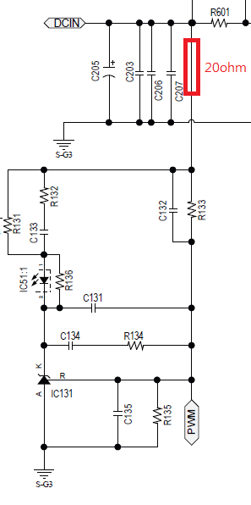
  - No Load測試，輸出端不接測試治具.
  - AC ON-OFF測試時，5V設定Von=3V，9V/12V/15V/20V設定Von=6V.
  - CC pin pulse width 測試 : 此tpulse1_bmc於0.4375V level時需符合1.4uS ~ 1.8uS範圍內。
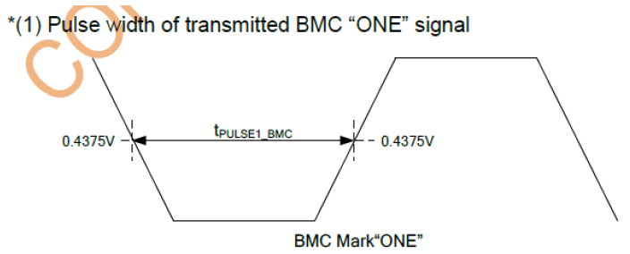
  - RFI與EMI測試架設擺放方式如下，熱機需用110Vac 20V3.25A，Burn-in 20min後測試。
AC cable 使用1.8m,不加阻抗匹配.接地線靠近插座處需加core並纏繞3ts,core型號C0900B-1

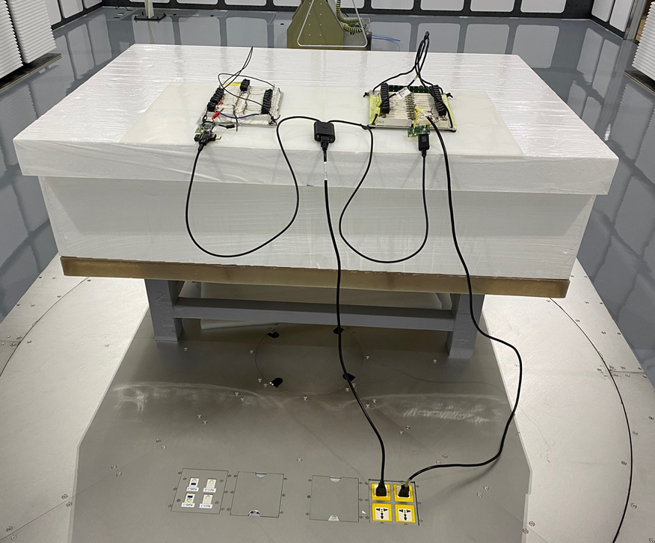
  - 表面溫度測試條件，電木貼鐵架，輸入電壓100V/60Hz，輸出負載Thermal Load，溫度線須使用#30號線, 溫度須滿足Δ50度。
  - 測試ATS/PLD/ESD/EFT時,治具板須掛1000uF/25V之系統電容.
  - 測試PLD/EFT時dummy load需接地。
  - 所以測試均須使用1m DC cable(Vender:JVE, Vender P/N: 1U-01108WA, 品名: USB-C 3.0 GEN1 male-male Cable)
  - Acoustic noise須使用自耦變壓器做測試並於輸出加掛1000uF 系統電容
另測試冷機時須測試0%,10%,20%,50%,100%load之噪音,熱機時只需測試50%,100%load之噪音.
  - 低溫測試只需滿足客戶規格0 degC,不需加嚴.
  - 因客戶的5V/9V系統不支援有線網路卡,故5V/9V輸出時不需測試ISN.

- 手調測試站：
  - Full Load Test：檢查滿載輸出是否符合規格。
  - Min Load Test：檢查輕載輸出是否符合規格。
  - OVP Test：(量產後不需測試)
測試方法: 由輸出外灌OVP test setup電壓(如下表)給Adapter,Adapter需保護,OVP動作模式為Latch off。如測試條件為兩組輸出時,任一組過電壓後兩組輸出必須同時保護.
NOMINAL OUTPUT | OVER VOLTAGE(spec) | OVP test setup
VOLTAGE (V) | MAXIMUM | Voltage(V)
5V | 8V | 7.4V
9V | 13.05V | 11.48V
12V | 15.80V | 15.14V
15V | 21.75V | 19.7V
20V | 29.00V | 25V

  - OTP Test：
測試方法：NTC701並聯6K ohm電阻，檢查輸出電壓是否Latch off。
  - AC On/Off：
Power supply 連續開關機 On= 5秒；Off= 5 秒各5次後，必須無損壞情形。
  - 抽載測試輸出：Connector需掛10uF & 1uF的輸出電容做為測試。
5. Function test (ATS) procedure：
Input Specification Table：
Input Voltage | Minimum | Maximum | Nominal(Rated)
90Vac~265Vac | 90Vac | 265Vac | 120Vac
Output Specification Table：
P1 / P2 | 0V(0) |  | 5V(1) |  | 9V(2) |  | 12V(3) |  | 15V(4) |  | 20V(5)
0V(0) | 0 / 0 |  | 0 / 65 |  | 0 / 65 |  | 0 / 65 |  | 0 / 65 |  | 0 / 65
0V(0) |  |  | X | 5V/3A | X | 9V/3A | X | 12V/5A | X | 15V/4.33A | X | 20V/3.25A
5V(1) | 65 / 0 |  | 30 / 30 |  | 30 / 30 |  | 30 / 30 |  | 20 / 45 |  | 20 / 45
5V(1) | 5V/3A | X | 5V/3A | 5V/3A | 5V/3A | 9V/3A | 5V/3A | 12V/2.5A | 5V/3A | 15V/3A | 5V/3A | 20V/2.25A
9V(2) | 65 / 0 |  | 30 / 30 |  | 30 / 30 |  | 30 / 30 |  | 20 / 45 |  | 20 / 45
9V(2) | 9V/3A | X | 9V/3A | 5V/3A | 9V/3A | 9V/3A | 9V/3A | 12V/2.5A | 9V/2.22A | 15V/3A | 9V/2.22A | 20V/2.25A
12V(3) | 65 / 0 |  | 30 / 30 |  | 30 / 30 |  | 30 / 30 |  | 20 / 45 |  | 20 / 45
12V(3) | 12V/5A | X | 12V/2.5A | 5V/3A | 12V/2.5A | 9V/3A | 12V/2.5A | 12V/2.5A | 12V/1.66A | 15V/3A | 12V/1.66A | 20V/2.25A
15V(4) | 65 / 0 |  | 45 / 20 |  | 45 / 20 |  | 45 / 20 |  | 30 / 30 |  | 30 / 30
15V(4) | 15V/4.33A | X | 15V/3A | 5V/3A | 15V/3A | 9V/2.22A | 15V/3A | 12V/1.66A | 15V/2A | 15V/2A | 15V/2A | 20V/1.5A
20V(5) | 65 / 0 |  | 45 / 20 |  | 45 / 20 |  | 45 / 20 |  | 30 / 30 |  | 30 / 30
20V(5) | 20V/3.25A | X | 20V/2.25A | 5V/3A | 20V/2.25A | 9V/2.22A | 20V/2.25A | 12V/1.66A | 20V/1.5A | 15V/2A | 20V/1.5A | 20V/1.5A
Test Plan:
 | P1 | P2
1 | X | 20V/3.25A
2 | X | 15V/4.33A
3 | 9V/2.22A | 20V/2.25A
4 | 15V/2A | 15V/2A
5 | 12V/1.66A | 15V/3A
6 | 5V/3A | 5V/3A

Test Item | Vin | Load | Spec | Remark
Inrush Current | 265V/63Hz;  Phase 90º | No load | shall be limited to a 29% margin of the I²T rating of the input fuse and bridge  rectifier.
Turn On Time | 90V/47Hz | 5V/3A | < 5Sec | Only output 5V  Only test C2 port
Hold up Time | 115V/60Hz | NA+20V/3.25A  NA+15V/4.33A  9V/2.22A+20V/2.25A  15V/2A+15V/2A  12V/1.66A+15V/3A  5V/3A+5V/3A | >5mSec
Rise Time | 90V/47Hz& 265V/63Hz | 0V to 5V  5V to 9V  5V to 12V  5V to 15V  5V to 20V | < 275mSes | Max Load  Only test C2 port
Fall Time | 90V/47Hz& 265V/63Hz | 5V/3A | N/A | Only output 5V
Line Regulation | 90/115/230/265V 47/60/50/63Hz | NA+20V/3.25A  NA+15V/4.33A  9V/2.22A+20V/2.25A  15V/2A+15V/2A  12V/1.66A+15V/3A  5V/3A+5V/3A | 19V ~ 21V(20V)  14.25V ~ 15.75V(15V)  11.4V ~ 12.6V(12V)  8.55V ~ 9.45V(9V)  4.5V ~ 5.25V(5V)
Load/Combine Regulation | 90/115/230/265V 47/60/50/63Hz | NA+20V/3.25A  NA+15V/4.33A  9V/2.22A+20V/2.25A  15V/2A+15V/2A  12V/1.66A+15V/3A  5V/3A+5V/3A | 19V ~ 21V(20V)  14.25V ~ 15.75V(15V)  11.4V ~ 12.6V(12V)  8.55V ~ 9.45V(9V)  4.5V ~ 5.25V(5V)
Overshoot | 90/115/230/265V 47/60/50/63Hz | NA+20V/3.25A  NA+15V/4.33A  9V/2.22A+20V/2.25A  15V/2A+15V/2A  12V/1.66A+15V/3A  5V/3A+5V/3A | 21 volts peak(20V)  15.75 volts peak(15V)  12.60 volts peak(12V)  9.45 volts peak(9V)  5.25 volts peak(5V) | During power-on or power-off, the output voltage shall be monotonically increasing or decreasing with  respect to the overshoot which shall neither each output volts peak nor be outside the regulation  requirements for more than 10ms.
Overshoot | 90/115/230/265V 47/60/50/63Hz |  | 5.6 volts peak(5V) | For 產線測試用
Ripple & Noise | 100V/50Hz | NA+20V/3.25A  NA+15V/4.33A  9V/2.22A+20V/2.25A  15V/2A+15V/2A  12V/1.66A+15V/3A  5V/3A+5V/3A | < 380mVp-p | 1uF/10uF/100uF(PD guideline)  Oscilloscope at 10KHZ to 20MHz bandwidth
Dynamic Load | 90V/47Hz & 265V/63Hz | NA+20V/3.25A  NA+15V/4.33A  9V/2.22A+20V/2.25A  15V/2A+15V/2A  12V/1.66A+15V/3A  5V/3A+5V/3A  Load condition:  0.1A~50%LOAD  50%~100%LOAD  0.1A~90%LOAD | 18.0V~22.0V(20V)  13.5V~16.5V(15V)  10.8V ~ 13.2V(12V)  8.1V ~ 9.9V(9V)  4.25V ~ 6V(5V) | slew rate is 1A/us,  Setting Time is 1Hz&5KHz  Duty Cycle 50%.  system capacitance 1000uF/50V
Short Circuit Protection | 90V/47Hz & 265V/63Hz | 0A & 5V/3A  9V/3A  12V/5A  15V/4.33A  20V/3.25A  Turn on then short | Latch off After 3sec
Over Current Protection | 90V/47Hz 265Vac/60Hz | NA+20V/3.25A  NA+15V/4.33A  9V/2.22A+20V/2.25A  15V/2A+15V/2A  12V/1.66A+15V/3A  5V/3A+5V/3A | Full load+0.1A~8A (Latch off) | 電流斜率0.1A/1.2S  Remark:不須計算CPK
Input Current | 90V/47Hz | NA+20V/3.25A  NA+15V/4.33A  9V/2.22A+20V/2.25A  15V/2A+15V/2A  12V/1.66A+15V/3A  5V/3A+5V/3A | < 1.6A
Average Efficiency | 115V/60Hz &  230V/50Hz | NA+20V/3.25A  NA+15V/4.33A  9V/2.22A+20V/2.25A  15V/2A+15V/2A  12V/1.66A+15V/3A  5V/3A+5V/3A | >89%  >89%  >86%  >86%  >86%  >81.7% | Cold/Hot  Remark:不須計算CPK  Remark:Vo須由adapter端取樣
Pin at No Load | 115V/60Hz&  230V/50Hz | No Load | < 100mW | Only output 5V
Pin at standby Load | 115V/60Hz&  230V/50Hz | 0.25W  0.5W  1.0W  1.5W | 0.5W  1.0W  1.7W  2.4W | 1. Only for 20V;  2. 0.25W cpk不判定.
Peak Load 1 | 100V/50Hz | 200% Load Ioc for 1mS, 5%Duty cycle | 17.0V~22.0V(20V)  12.5V~16.5V(15V)  9.8V ~ 13.2V(12V)  7.1V ~ 9.9V(9V) | For cable END measurement.  (low current equals 95% Ioc for 19ms)  Remark:不須計算CPK
Peak Load 2 | 100V/50Hz | 175% Load Ioc for 2mS, 10%Duty cycle | 17.0V~22.0V(20V)  12.5V~16.5V(15V)  9.8V ~ 13.2V(12V)  7.1V ~ 9.9V(9V) | For cable END measurement.  (low current equals 92% Ioc for 18ms)  Remark:不須計算CPK
Peak Load 3 | 100V/50Hz | 150% Load Ioc for 10mS, 50%Duty cycle | 17.0V~22.0V(20V)  12.5V~16.5V(15V)  9.8V ~ 13.2V(12V)  7.1V ~ 9.9V(9V) | For cable END measurement.  (low current equals 50% Ioc for 10ms)  Remark:不須計算CPK
AC Line cycle dropout | 115V/60Hz | NA+20V/3.25A  NA+15V/4.33A  9V/2.22A+20V/2.25A  15V/2A+15V/2A  12V/1.66A+15V/3A  5V/3A+5V/3A | 19V ~ 21V(20V)  14.25V ~ 15.75V(15V)  11.4V ~ 12.6V(12V)  8.55V ~ 9.45V(9V)  4.5V ~ 5.25V(5V)
Note 1: After completes required DVT test matrix, identifies and selects the worst case condition for the Production
MTR. It is not required that all test conditions be tested. Example: If worst case condition for Output Ripple is
minimum input voltage and maximum dc load, then that is the test condition to be used.

6. Safety
6.1 Hi-POT test：
6.1.1 Primary to Secondary use 3000+10% Vac. (Rise time：DC=1Sec, AC=0.1Sec)
Cut off current : Hi-Limit 10mA, Lo-Limit 0.02mA.
Note: Testing time for production line is 1 minute at EVT/DVT stage and 1 Second at PVT/MP stage.
Following is Arcing sense setting at each stage : EVT1: 8mA, EVT2/DVT: 10mA, PVT/MP: 12mA
6.2 Insulation Resistance (IR)test:
Primary to Secondary use 500Vdc test, Insulation resistance limit >100Mohm
6.3 Leakage Current test :
250Vac/50Hz <= 40uA。
6.4 Surface temperature :
測試條件:100Vac/50Hz Amb=35C,表面溫升需<= 50degC。

7. Burn-in 測試作業規範
7-1. Ambient is 35℃, Vin = 220Vac , 80% rated load。
7-2. Burn-in 時間定義
7-2-1. P/R階段B/I時間24 hours，每2 hours循環一次，輸出電壓與B/I時間分配如下 :
(1).輸出電壓5V，B/I時間0.125 hours。
(2).輸出電壓9V，B/I時間0.125 hours。
(3).輸出電壓12V，B/I時間0.125 hours。
(4).輸出電壓15V，B/I時間0.125 hours。
(5).輸出電壓20V，B/I時間1.5 hours。
7-2-2. MP階段B/I時間根據產品的品質穩定性調整B/I時間。

8. USB Connecter Pin定義與相關測試
  - Pin定義與描述：
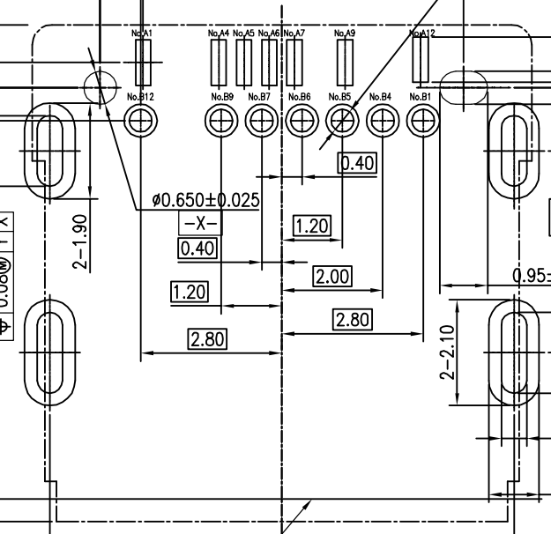
USB Connecter示意圖
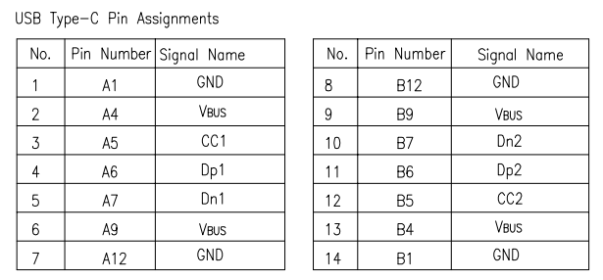
USB Connecter Pin說明.
  - ：相關測試：
- . 各PIN 短路開路定義
GND Pin：A1，B1，A12，B12需短路。VBUS Pin：A4，B4，A9，B9需短路。
CC Pin：A5，B5。其餘未定義的各Pin開路。

9. 瓦數分配
因兩組電壓同時輸出時, 在以下條件時需瓦數分配(設計為error recovery).
- 開機時, 兩port type C同時接著. (第一組會由單port 65W, 重新定義為20W or 45W)
因開機CPU有機率沒讀到第一組port宣告”單port 65W”, 故有可能不重啟
以下為開機時波形
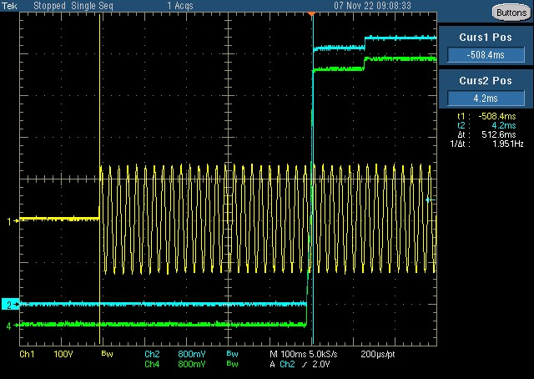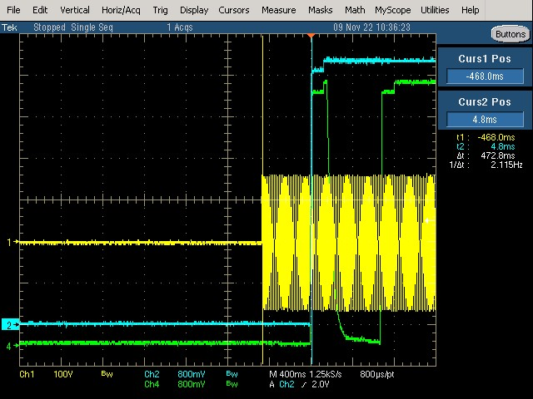
- 開機後, 兩port type C分別插入. (第一組會由單port 65W, 重新定義為30W)
- 開機後, 兩port type C拔除任一組輸出. (剩餘port重新定義為65W)
- 開機後, 兩port type C任一組輸出切電壓.(5V/9V為20W, 12V/15V/20V為45W)

